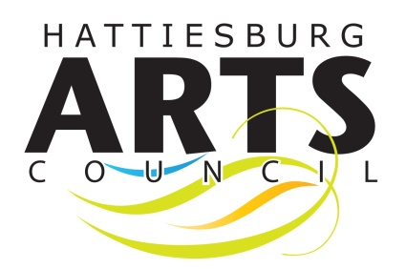
Application Form
2022 EMERGING ARTISTS EXHIBITION
Submission deadline: October 14th, 2022
Remit this form along with your checklist of items below
via email to: hattiesburgartscouncil@gmail.com

NAME: ___________________________________________________ AGE: ___________________

ADDRESS: ________________________________________________________________________

MOST REACHABLE PHONE NUMBER: ___________________________________________________

EMAIL: ___________________________________________________________________________

MEDIUM: ________________________________________________________________________

SCHOOL (if applicable): ______________________________________________________________

Checklist:
All artwork submissions should be completed within the last year.

Visual Artists - 3 to 5 images of your artwork
(The images should be saved in JPEG format at 72dpi, with no image wider than 1240 pixels)

Writers - Need to send at least one JPEG image of your book(s), along with examples of the literature

Performers* - Submit a 5-10 minute CD or DVD of a performance idea to be performed at the exhibition opening, or a CD that will be available for purchase

- Please include a list of submitted work that includes title, size, (or, the name of your book/CD, act/performance), price, or NFS (20% of all sells will go to help support the HAC)
- Once selected, all eligible submissions* must be delivered to:
Hattiesburg Cultural Center, 723 North Main Street, Hattiesburg, MS 39401
Monday, November 9th - Tuesday, November 10th, 2020 from 10am-5pm
All visual artwork should be labeled and “ready to hang” with one wire across the back (No saw-tooth hangers will be accepted)

*Performance oriented artists will be contacted individually, concerning further instructions.

